Name ____________________________

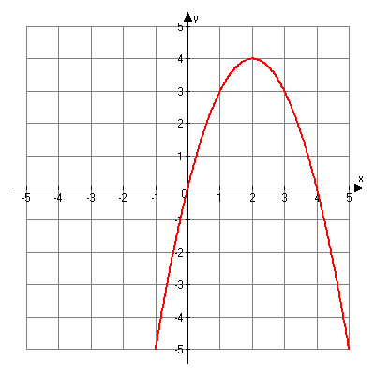

*You are an engineer for HsiehMoore Labs. Our lab needs a device that consistently launches a small ball (e.g. golf, tennis, lacrosse) 5-30 ft. straight up in the air. As an engineer, you will use your knowledge of quadratics to analyze the flight of this ball.*

**Requirements:**

1. Create/modify a device that will launch a ball straight up into the air (10-30 ft). The device must be consistent in launching the ball nearly the same height each time.
2. Conduct 5+ in-class trials to determine the average flight time of the ball.
3. Use the data from step 2 to create a quadratic equation describing height in terms of time.

*h = -16t2 + v0t + h0*

*h= height in feet t= time in seconds v0= initial velocity h0= initial height*

1. Make a table and graph matching the quadratic equation. Indicate max/min, x and y-int., line of symmetry.
2. Calculate the max height for the ball. Show your work. Test your max height in class for accuracy.
3. Write up questions:   
   a) The maximum height predicted by my equation, table, and graph was ______________.   
   After the second launch, we found the prediction was _______(correct/incorrect).
4. Some variables that may have affected the results: _________________.
5. From this project, I learned ___________. I still do not really understand ________________.

**Rubric:**

*I can connect quadratic tables, graphs, and equations.*

_____ 6: Exceptional: Accurate, complete, labeled, includes factoring of quadratic equation.

_____ 5: Accomplished: Accurate, complete, labeled, thoroughly connects equation with graph/table.

_____ 4: Sufficient: Complete, mostly accurate with minor errors or labels missing.

_____ 3: Developing: Equation, table, or graph incomplete, major mathematical errors.

_____ 2: Insufficient: Equation, table, or graph missing, major mathematical errors.

_____ 1: Minimal: Little effort is made to connect graph, table, and equation.

*I can simplify/solve quadratic expressions.*

_____ 6: Exceptional: Accurate equation, all work shown, and includes factoring of quadratic equation.

_____ 5: Accomplished: Accurate equation, all work shown, max height matches calculations.

_____ 4: Sufficient: Accurate equation, most work shown, max height may not match calculations.

_____ 3: Developing: Equation has minor errors, work not shown for writing quadratic equation.

_____ 2: Insufficient: Equation is not accurate nor quadratic, work not adequately shown.

_____ 1: Minimal: No equation is clearly written.